Table of Contents

Experimental context 2

Synthesis 2

Preparation and characterization 2

Modification of silica via incipient wetness impregnation 2

Incipient wetness impregnation of Rh4(CO)12 3

Reactor preparation for test 4

Measurement/Data collection 4

Data processing 5

R-script 6

Explanation of data sheet xs_vs_TOS Dino Run 46 6

Nomenclature and description of the data sheet features 10

# 

# Experimental context

Aim of the experimental run is the investigation of the catalytic behavior of four different catalysts during the conversion of synthesis gas to ethanol.

# Synthesis

## Preparation and characterization

### Modification of silica via incipient wetness impregnation

The samples 1–3 were prepared according to literature known procedures for StE catalysts[10,18,23]. Calcination and reduction programs are shown in Table 1.

**Table 1:** Calcination and reduction program.

|  |  |  |  |  |
| --- | --- | --- | --- | --- |
|  | Calcination | | Reduction | |
| Gas atmosphere | 20% O2/N2  (500 ml/min) | | 10% H2/N2  (500 ml/min) | |
| Ramp | 5 K/min | | 5 K/min | |
| Steps | 80 °C | 0.5 h | 260 °C | 2 h |
|  | 100 °C | 0.5 h |  | |
|  | 120 °C | 3 h |  | |
|  | 350 °C | 3 h |  | |

#### Preparation of MnOx/SiO2

Mn(II) nitrate tetrahydrate (208.4 mg, 830.2 µmol, 1.5 wt% Mn) was dissolved in water (2.70 mL, HPLC grade). The solution was added dropwise to the silica-support (550s, 3.009 g, 50.05 mmol) while stirring with a spatula. Then the impregnated silica was stirred for additional 19 min until it was dry. The sample was calcined and reduced afterwards according to Table Table.

|  |  |
| --- | --- |
| **ICP-OES** (wt%): | **Mn:** 1.61 ± 0.01 |

#### Preparation of FeOx/SiO2

FeOx/SiO2 *was* prepared via incipient wetness impregnation as described for sample **1**. Iron(III) nitrate nonahydrate (321.0 mg, 794.6 µmol, 1.5 wt% Fe) was dissolved in water (2.75 mL, HPLC grade) and impregnated on silica (550s, 3.002 g, 49.94 mmol). Calcination and reduction were processed according to table Table.

|  |  |
| --- | --- |
| **ICP-OES** (wt%): | **Fe:** 1.40 ± 0.01 |

#### Preparation of (Mn,Fe)Ox/SiO2

(Mn,Fe)Ox/SiO2wasprepared via incipient wetness impregnation as described for sample **1**. Iron(III) nitrate nonahydrate (321.1 mg, 794.8 µmol, 1.5 wt% Fe) and manganese(II) nitrate (208.9 mg, 832.2 µmol, 1.5 wt% Mn) were dissolved in water (2.70 mL, HPLC-grade) and impregnated to silica (550s, 3.001 g, 49.93 mmol). Calcination and reduction were processed according to table Table.

|  |  |  |
| --- | --- | --- |
| **ICP-OES** (wt%): | **Mn:** 1.49 ± 0.01 | **Fe:** 1.44 ± 0.01 |

### Incipient wetness impregnation of Rh4(CO)12

#### Preparation of silica-supported Rh4(CO)12

The impregnation of Rh4(CO)12 was carried out via the incipient wetness impregnation method as follows. Rh4(CO)12 (70.6 mg, 94.4 µmol, 2.8 wt% Rh) was dissolved in purified dichloromethane (3 × 1.23 mL). A third part of the Rh4(CO)12-solution (1.23 mL) was added dropwise to silica (550s, 1.366 g, 22.73 mmol). After drying the silica in high vacuum at room temperature for 1 h, impregnation, and drying was repeated two more times. After the last impregnation step, the sample was dried for 17 h.

|  |  |  |  |  |  |  |
| --- | --- | --- | --- | --- | --- | --- |
| **TPDe-MS** (10% H2/Ar): | T1,max: 185 °C (T1,onset: 141 °C, *m/z 28, m/z 12*); T2,max: 323 °C (T2,onset: 238 °C, *m/z 16, m/z 12*). | | | | | |
| **TPDe-MS** (Ar): | Tmax: 181 °C(Tonset: 145 °C, *m/z 28, m/z 12*) | | | | | |
| **HP-TG** (H2): | **1 bar:** T1,max: 139 °C (T1,onset: 122 °C), T2,max: 243 °C (T2,onset: 201 °C)  **4 bar:** T1,max: 147 °C (T1,onset: 127 °C), T2,max: 213 °C (T2,onset: 193 °C) | | | | | |
| **HP-TG** (Ar): | **1 bar:** Tmax: 165 °C (Tonset: 146 °C) | | | | | |
| **HP-TG** (CO): | **1 bar:** Tmax: 228 °C (Tonset: 218 °C)  **4 bar:** Tmax: 234 °C (Tonset: 225 °C) | | | | | |
| **CHN** (wt%): | **C:** | 0.6 ± 0.5 | **H:** | 0.01 ± 0.02 | **N:** | 0.00 |
| **FTIR** (*v*/cm-1): | 3747 (m), 2086 (m), 1802 (w), 1107(vs), 824 (s), 471(s) | | | | | |
| **ICP-OES** (wt%): | Rh: 2.12 ± 0.02 | | | | | |

#### Preparation of MnOx/SiO2-supported Rh4(CO)12

Rh4(CO)12 (71.9 mg, 96.2 µmol, 2.9 wt% Rh) was impregnated via incipient wetness impregnation on sample **1** (1.363 g, 22.68 mmol) according to the method described for sample **A**.

|  |  |  |  |  |  |  |  |
| --- | --- | --- | --- | --- | --- | --- | --- |
| **TPDe-MS** (10% H2/Ar): | T1,max: 174 °C (T1,onset: 130 °C, *m/z 28, m/z 12*); T2,max: 263 °C(T2,onset: 215 °C, *m/z 16, m/z 12*) | | | | | | |
| **TPDe-MS** (Ar): | Tmax: 175 °C (Tonset: 141 °C, *m/z 28, m/z 12*). | | | | | | |
| **HP-TG** (H2): | **1 bar:** T1,max: 123 °C (T1,onset: 94 °C), T2,max: 185 °C (T2,onset: 167 °C)  **4 bar:** T1,max: 132 °C (T1,onset: 102 °C), T2,max: 191 °C (T2,onset: 175 °C) | | | | | | |
| **HP-TG** (Ar): | **1 bar:** Tmax: 153 °C (Tonset: 116 °C) | | | | | | |
| **HP-TG** (CO): | **1 bar:** Tmax: 213 °C (Tonset: 199 °C)  **4 bar:** Tmax: 222 °C (Tonset: 208 °C) | | | | | | |
| **CHN** (wt%): | **C:** | 0.4 ± 0.1 | **H:** | 0.1 ± 0.1 | | **N:** | 0.00 |
| **FTIR** (*v*/cm-1): | 3745 (m), 2087 (m), 2026 (w), 1798 (w), 1091 (vs), 826 (s),  476 (s). | | | | | | |
| **ICP-OES** (wt%): | **Rh:** 2.52 ± 0.01 | | | | **Mn:** 1.54 ± 0.01 | | |

#### Preparation of FeOx/SiO2-supported Rh4(CO)12

Rh4(CO)12 (55.0 mg, 73.6 µmol, 2.8 wt% Rh) was impregnated via incipient wetness impregnation on sample **2** (1.049 g, 17.45 mmol) according to the method described for sample **A**.

|  |  |  |  |  |  |  |  |
| --- | --- | --- | --- | --- | --- | --- | --- |
| **TPDe-MS** (10% H2/Ar): | T1,max: 179 °C (T1,onset: 142 °C, *m/z 28, m/z 12*); T2,max: 317 °C(T2,onset: 224 °C, *m/z 16*). | | | | | | |
| **TPDe-MS** (Ar): | Tmax: 178 °C (Tonset: 151 °C, *m/z 28, m/z 12*). | | | | | | |
| **CHN** (wt%): | **C:** | 0.31 ± 0.07 | **H:** | 0.10 ± 0.06 | | **N:** | 0.00 |
| **FTIR** (*v*/cm-1): | 3745 (m), 2961 (w), 2859 (w), 2085 (m), 2026 (w), 1798 (w), 1127 (vs), 819 (s), 472 (s). | | | | | | |
| **ICP-OES** (wt%): | **Rh:** 2.52 ± 0.01 | | | | **Fe:** 1.48 ± 0.01 | | |

#### Preparation of (Mn,Fe)Ox/SiO2-supported Rh4(CO)12

Rh4(CO)12 (71.7 mg, 95.9 µmol, 2.9 wt%) was impregnated via incipient wetness impregnation on sample **3** (1.359 g, 22.61 mmol) according to the method described for sample **A**.

|  |  |  |  |  |  |  |  |
| --- | --- | --- | --- | --- | --- | --- | --- |
| **TPDe-MS** (10% H2/Ar): | T1,max: 168 °C (T1,onset: 126 °C, *m/z 28, m/z 12*); T2,max: 266 °C(T2,onset: 220 °C, *m/z 16*). | | | | | | |
| **TPDe-MS** (Ar): | Tmax: 182 °C (Tonset: 144 °C, *m/z 28*). | | | | | | |
| **CHN** (wt%): | **C:** | 0.27 ± 0.03 | **H:** | 0.11 ± 0.05 | | **N:** | 0.00 |
| **FTIR** (*v*/cm-1): | 3745 (m), 2085 (m), 2033 (w), 1800 (w), 1091 (vs), 824 (s), 468 (s). | | | | | | |
| **ICP-OES** (wt%): | **Rh:** 2.46 ± 0.01  **Fe:** 1.46 ± 0.01 | | | | **Mn:** 1.46 ± 0.01 | | |

# Reactor preparation for test

Assemble reactors (connect reactor head and reactor tube) -> Pressure check

Check passed -> fill Steatite up to position of catalyst bed -> fill in catalyst -> fill steatite to end of tube -> close with frit and Madenschraube.

Mount the reactors -> pressure check with N2 -> 2 steps

Pressure check okay -> change to desired start up feed -> wait for equilibration/steady state -> heat reactor to desired temperature

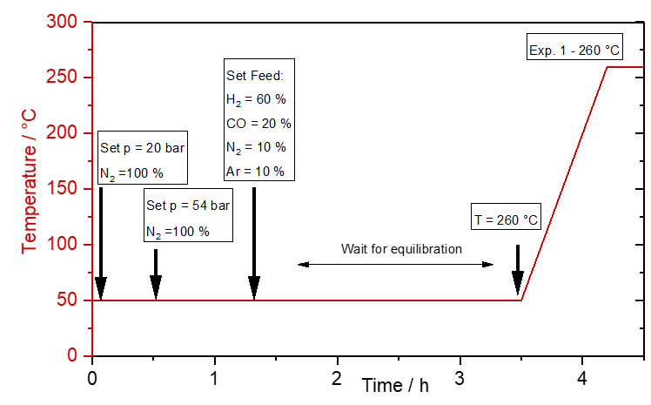

# Measurement/Data collection

Before the run, a DoE/test protocol is created. It defines the process parameter under which the catalyst is evaluated. Software: ProControl “Compass” / Control PC

Wait feed to equilibrate ~ 4 h each time a condition is changed.

Measure gas concentration of all reactors + BP 5 times 5 x(1 -> 2 -> 3 -> 4 -> BP), each measurement ~35 min  
* The gas concentration was measured via Gas Chrormatography every xx minutes

GC: Agilent 7890   
* For each GC measurement a separate file of the data recorded by the instrument was stored in GC PC

Process parameters are recorded in Control PC by ProControl Software – the same software is used for the recipe and changing the conditions/run the experiment

# Data processing

* Each GC file was "integrated" via XX software to obtain a text file that contains the peak areas assigned to each product species

The GC has calibration values saved and converts peak area to concentration

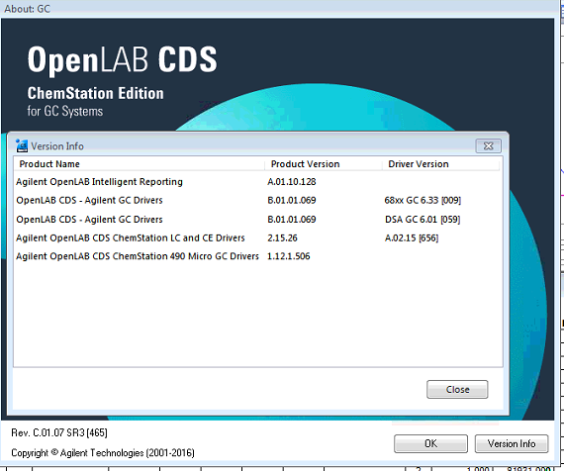 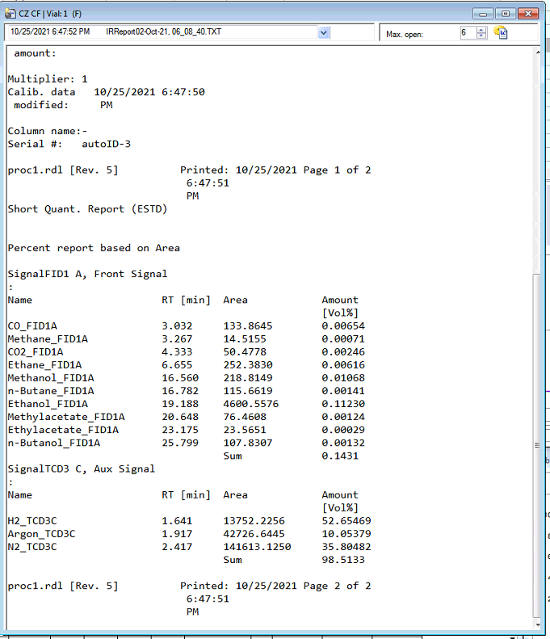

Each report is sent from the GC PC to the Control PC automatically

ProControl Software “Helix” matches GC and Process data

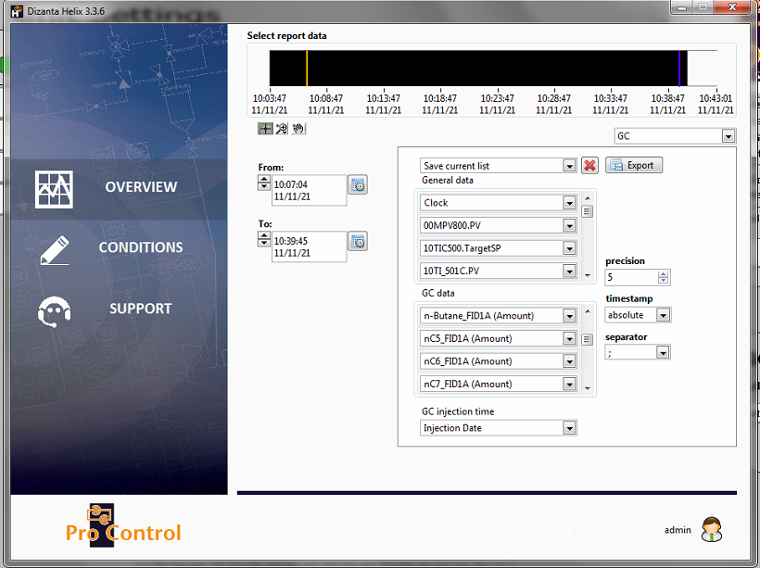

Helix creates a .csv file with the matched Process+GC data -> “raw” data file

“raw” data file created with Helix and stored of ProcessPC is transferred to “Office/AFS” PC by USB Stick

R.script is “applied” to Raw data file …. -> excel (multiple sheets raw_data, concentrations_overview, …) file

* A customized script programmed in R was run to collect all the GC files, match them with the experimental procedure, process them into gas concentrations and other numbers, and assemble them into one XLS thaz   
summarizes the experimental results.

R-script  
* (write here in chronological order one sentence for each block of the script)

# The following documentation describes the output generated by the R_script, specifically the sheet_XvsTOS

# The nomenclature of the R_script it described in section XX of the DOC

1. assign experiment numbers and separate data into blocks of the experiments

2. Apply internal standard -> get real concentration (before, reactor outlet diluted with N2 -> not the “real” concentration) BP is not diluted -> use as “reference” to calculate back

3. Calculate conversion, selectivity, c-balance for each experiment

4. Put data together

xs_vs TOS

5. export as excel

# Explanation of data sheet xs_vs_TOS Dino Run 46

The data in the sheet can be categorized into two parts:

1. Process data and/or data calculated using process data
2. GC data and/or data calculated using GC data

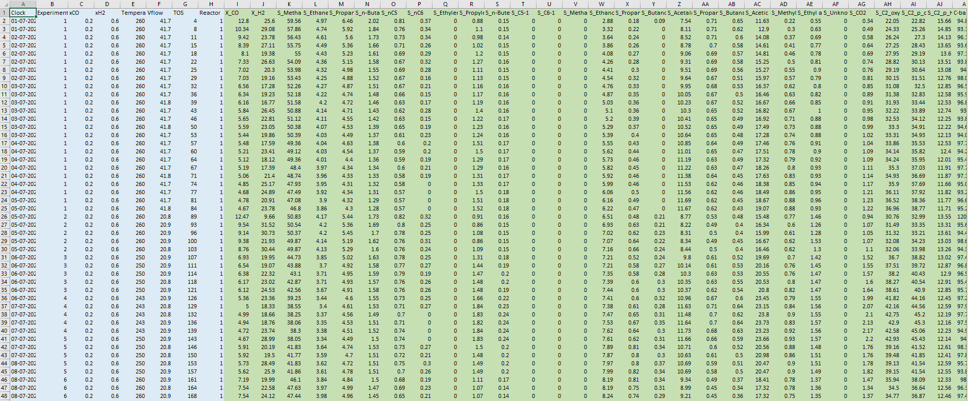

In the following, each category will be explained in more detail.

Process data and/or data calculated using process data

During a catalytic test (“Run”, “Plate the catalyst performance is evaluated under different conditions. Commonly varied parameters are temperature, GHSV/Flow, feed composition, pressure.

Before the run, a DoE/test protocol is created. It defines the process parameter under which the catalyst is evaluated. Every parameter change is defined as a new experiment. For each experiment the DoE defines furthermore the number measurements.

Typically, a 3-5 measurements are performed for each experiment. If the catalyst is not stable initially, more measurements can be taken until a stable performance is reached.

In the current example, each experiment and the changed process parameter is highlighted in different shades of yellow. During the equilibration, 24 measurements were taken and for the following experiments 4-5 measurements.

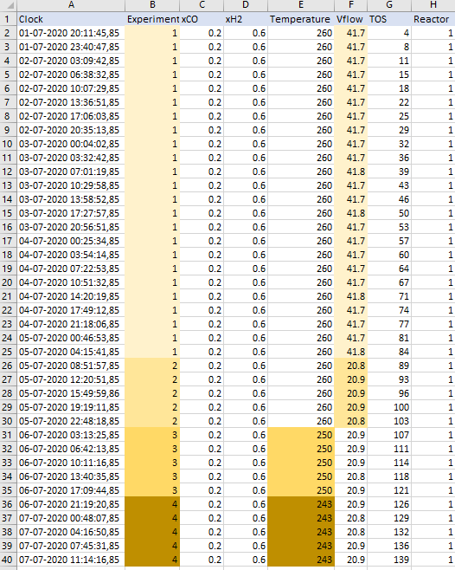

For each measurement, a new row is created in the excel sheet. The time of the sampling/measurement is recorded as a time stamp in the column A/”Clock”. By subtracting the sampling time from the start of the catalytic test, the “Time on stream” (column A/”TOS”) can be calculated. In the example the TOS is given in hours.



Furthermore, values of selected process parameters at the time of sampling are recorded. In the example the parameter “xCO” and “xH2” describe the feed composition, “Temperature” the set-point of the reactor temperature and “Vflow” the volumetric flow through the reactor.



The catalytic set-up described here is a 4-fold parallel reactor with an additional bypass line for feed quantification. The measurements/experiments in the data sheet are grouped by reactor number (“Reactor”/Column H), starting with reactor 1. After the last measurement of experiment 7 in row 55, the sheet continues with the data for reactor 2, starting again with experiment 1. For simplicity reasons, the bypass has no extra name, but the reactor number “5”.

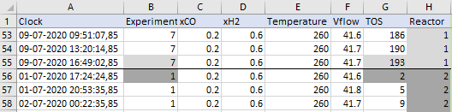

GC data and/or data calculated using GC data

This part of the sheet contains data derived/calculated from GC (Gas Chromatograph). In the GC educts and products formed in the reaction appear as peaks in the chromatogram. The compounds have different retention times and from calibrations done prior the run the areas of the peaks can be converted into concentrations

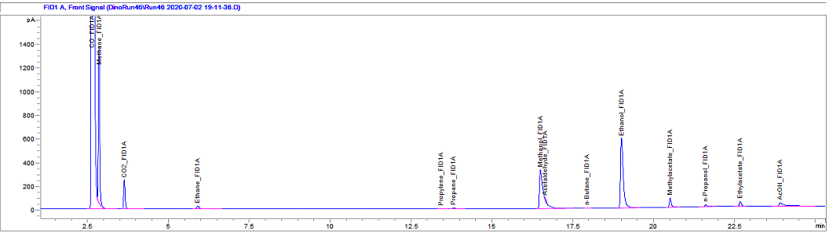

**Figure 1.** Example Chromatogram

From the concentrations different descriptors can be calculated. The columns “I” and “J” contain the conversion of CO (X_CO) and H2 (X_H2) for each measurement. The conversion describes, how much of the educt was consumed in the reaction and is given in “%”. If the conversion is “0”, no CO and H2 was consumed, and no products were formed. If the conversion is “100 %” all the educts was converted.

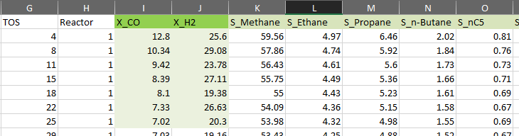

Another important and commonly used descriptor is the selectivity. The selectivity describes the product distribution of the compounds formed in the reaction from the educt. The columns “K” to “AG” contains the selectivity to the compound specified in the header, e.g., “S_**Methane**” in “%”. In the example below this means, that 59.56 % of the CO consumed in the reaction was converted to methane.

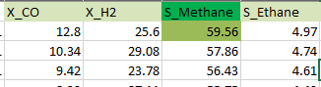

The columns “AH”, “AI” and “AJ” contain selectivities of product groups, which are of special interest for the investigated type of reaction. In case of “S_C2_oxy” this is the sum of the selectivities of “S_**Ethanol**” (Column W), “S_**Acetaldehyde**”(Column Z) and “S_**Acetic acid**”(Column AC).

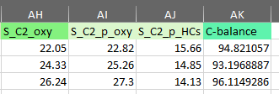

“C-balance” (Column AK) stands for carbon balance or carbon recovery and is calculated by dividing the moles of carbon detected in the reactor outlet by the moles of carbon entering the reactor.

# Nomenclature and description of the data sheet features

|  |  |  |  |
| --- | --- | --- | --- |
| **Name of data feature** | **definition** | **unit** | **Origin of data** |
| Clock | Showing date (day-month-year) and time for recoding respective row |  | Read from computer in test lab (GC Report) |
| Experiment | Specifying a unique combination of test parameters |  | Assigned by R.script |
| xCO | Volumetric ratio of CO in feed | %V | Calc. by R.Script |
| xH2 | Volumetric ratio of H2 in feed | %V |  |
| Temperature | Designated rxn temperature from DOE | °C | Process PC/Software |
| Vflow | Volumetric flow entering each reactor | ml/min | Process PC -> Calc. by R.Script |
| TOS | Current time since start of the run | H | Timestamp from GC -> Calc. by R.Script |
| Reactor | Assigned number to the reactor |  | Process PC |
| X_CO | CO conversion, calculated by the R-script | % | Computed with R-script |
| X_H2 | H2 conversion, calculated by the R-script | % | Computed with R-script |
| S_Methane | Selectivity to methane | % | Computed with R-script |
| S_Ethane | Selectivity to ethane | % | Computed with R-script |
| S_Propane | Selectivity to propane | % | Computed with R-script |
| S_n-Butane | Selectivity to n-butane | % | Computed with R-script |
| S_nC5 | Selectivity to pentane | % | Computed with R-script |
| S_nC6 | Selectivity to hexane | % | Computed with R-script |
| S_Ethylene | Selectivity to ethylene | % | Computed with R-script |
| S_Propylene | Selectivity to propylene | % | Computed with R-script |
| S_n-Butene | Selectivity to n-butene | % | Computed with R-script |
| S_C5-1 | Selectivity to pentene | % | Computed with R-script |
| S_C6-1 | Selectivity to hexane | % | Computed with R-script |
| S_Methanol | Selectivity to methanol | % | Computed with R-script |
| S_Ethanol | Selectivity to ethanol | % | Computed with R-script |
| S_Propanol | Selectivity to propanol | % | Computed with R-script |
| S_Butanol | Selectivity to butanol | % | Computed with R-script |
| S_Acetaldehyde | Selectivity to acetaldehyde | % | Computed with R-script |
| S_Propanal | Selectivity to propanal | % | Computed with R-script |
| S_Butanal | Selectivity to butanal | % | Computed with R-script |
| S_Acetic acid | Selectivity to acetic acid | % | Computed with R-script |
| S_Methyl acetate | Selectivity to methyl acetate | % | Computed with R-script |
| S_Ethyl acetate | Selectivity to ethyl acetate | % | Computed with R-script |
| S_Unknown | Selectivity to un-assigned peaks from GC | % | Computed with R-script |
| S_CO2 | Selectivity to CO2 | % | Computed with R-script |
| S_C2_oxy | Selectivity to oxygenates with 2 carbon atoms in their structure | % | Computed with R-script |
| S_C2_p_oxy | Selectivity to oxygenates with 2 and more than 2 carbon atoms in their structure | % | Computed with R-script |
| S_C2_p_HCs | Selectivity to hydrocarbons with 2 and more than 2 carbons in their structure | % | Computed with R-script |
| C-balance | Carbon balance, based on (CO_out + carbon containing products)/CO_in | % | Computed with R-script |